NAMA : SUKMA LARASATI

NIM : K3521066

KELAS : B

MATA KULIAH : DESAIN WEB

**LABWORK 6**

1. **Latihan 1**

* Latihan 1a

Script HTML

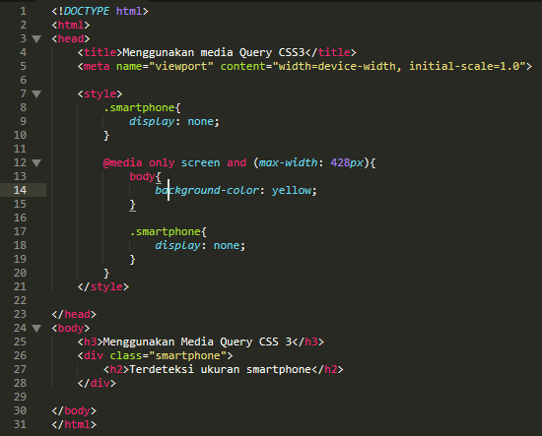

Ukuran desktop

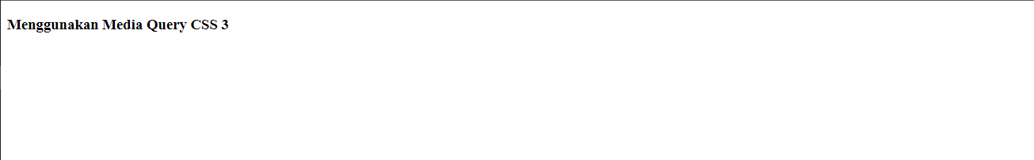

Ukuran smartphone

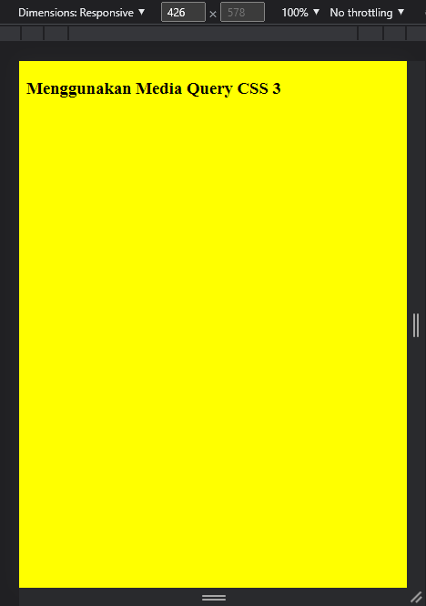

* Latihan 1b

Script HTML

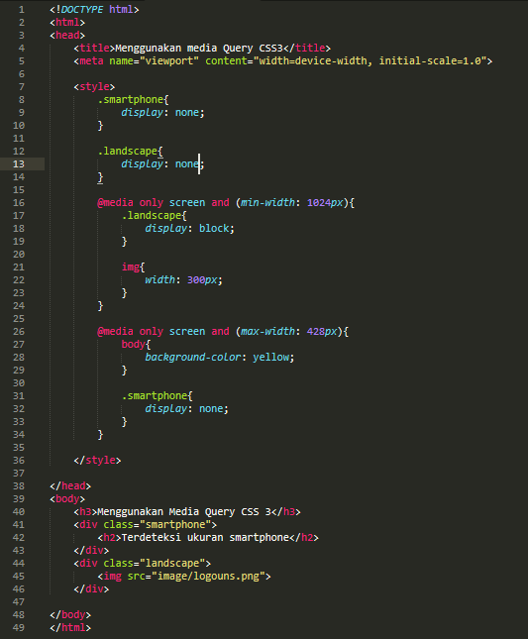

Ukuran desktop



Ukuran smartphone

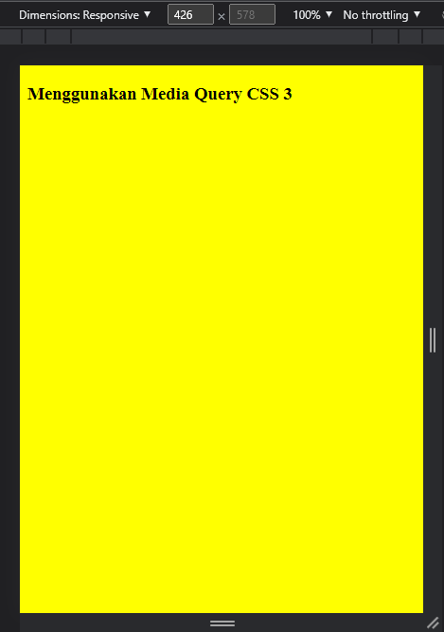

1. **Latihan 2**

* Latihan 2a

Script HTML

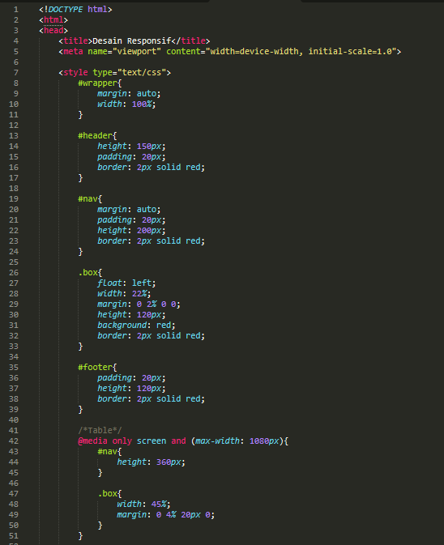

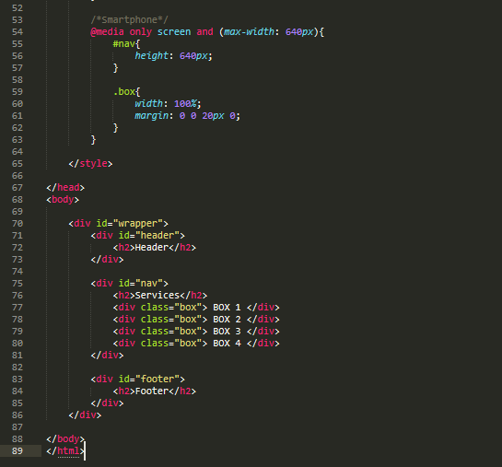

Ukuran desktop

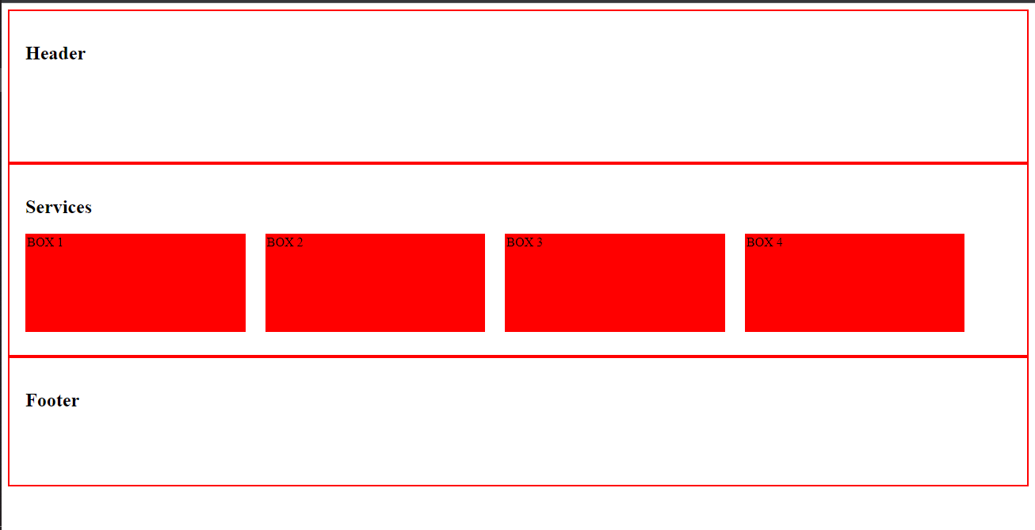

Ukuran tablet

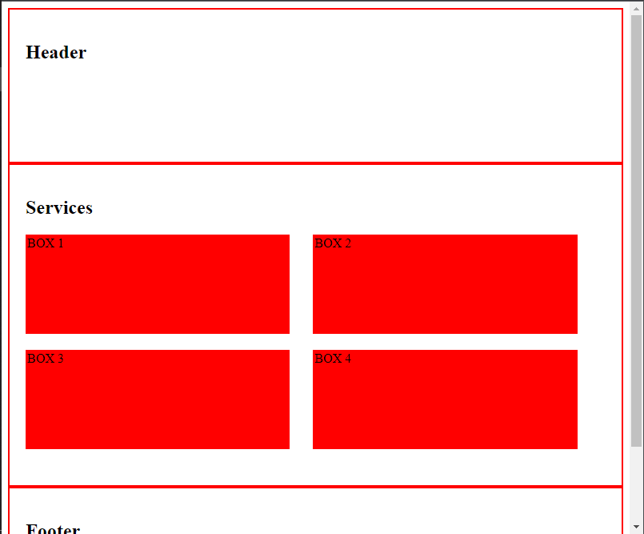

Ukuran smartphone

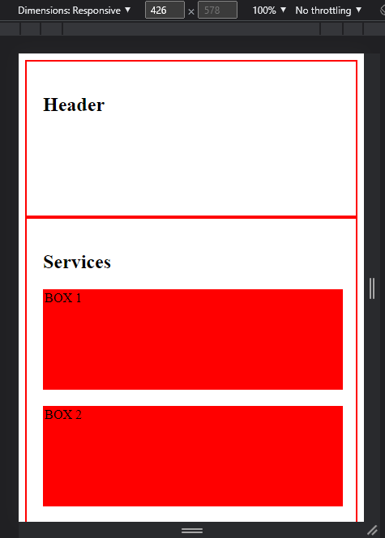

* Latihan 2b

Script HTML

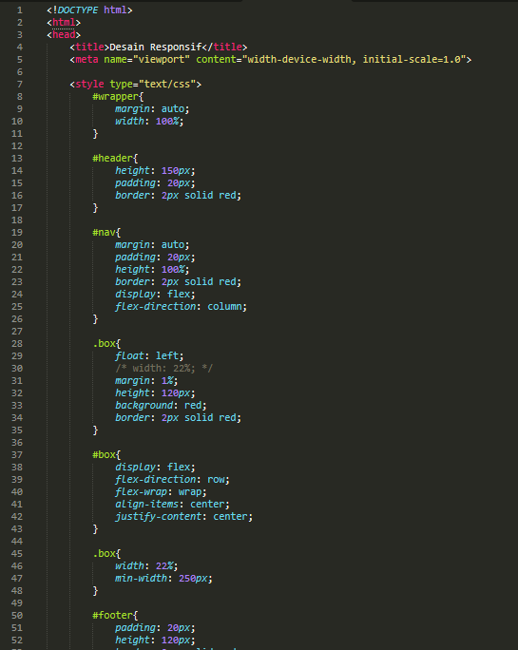

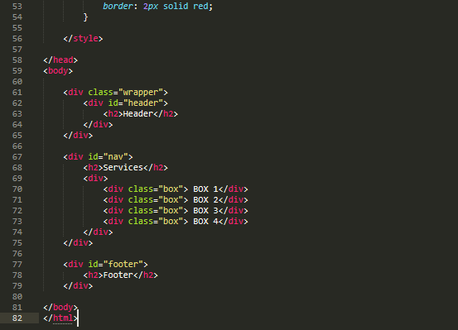

Ukuran desktop

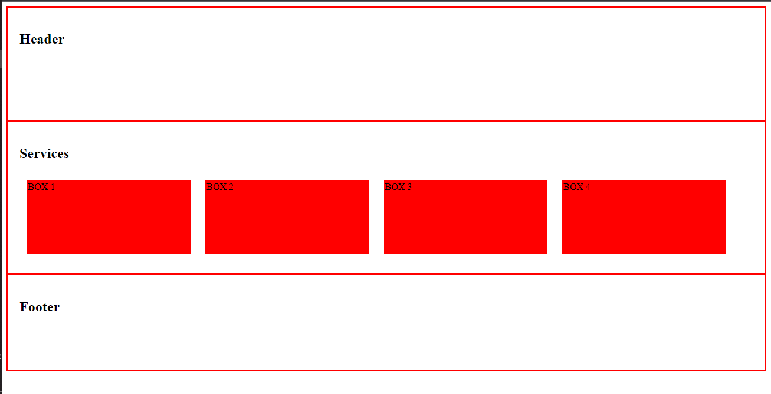

Ukuran tablet

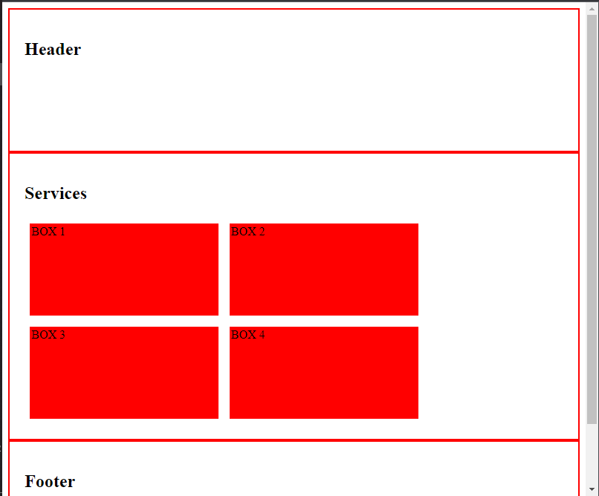

Ukuran smartphone

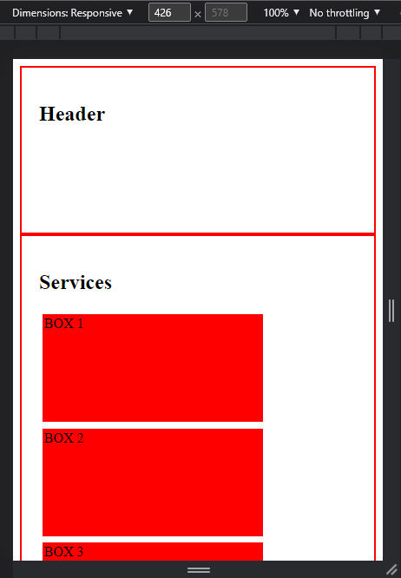

1. **Latihan 3**

* Latihan 3a

Script HTML

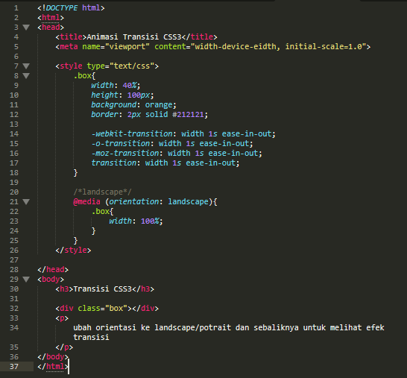

Ukuran desktop

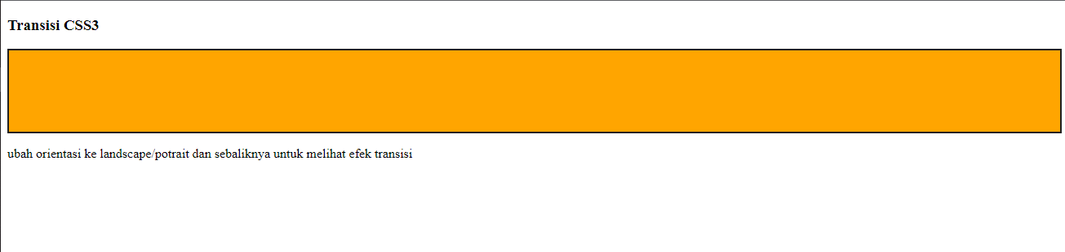

Ukuran smartphone

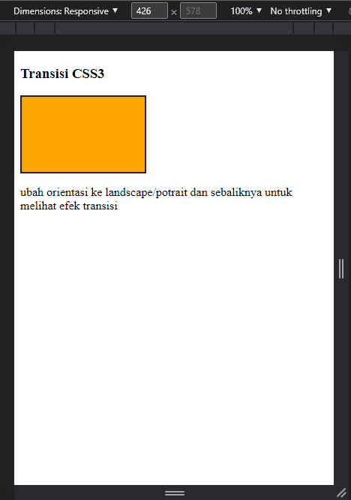

* Latihan 3b

Script HTML

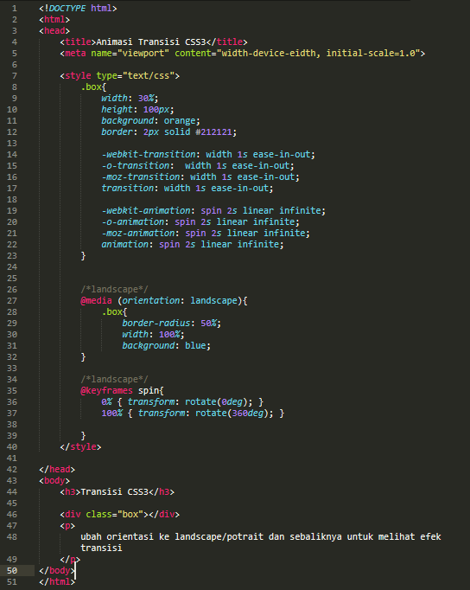

Ukuran desktop

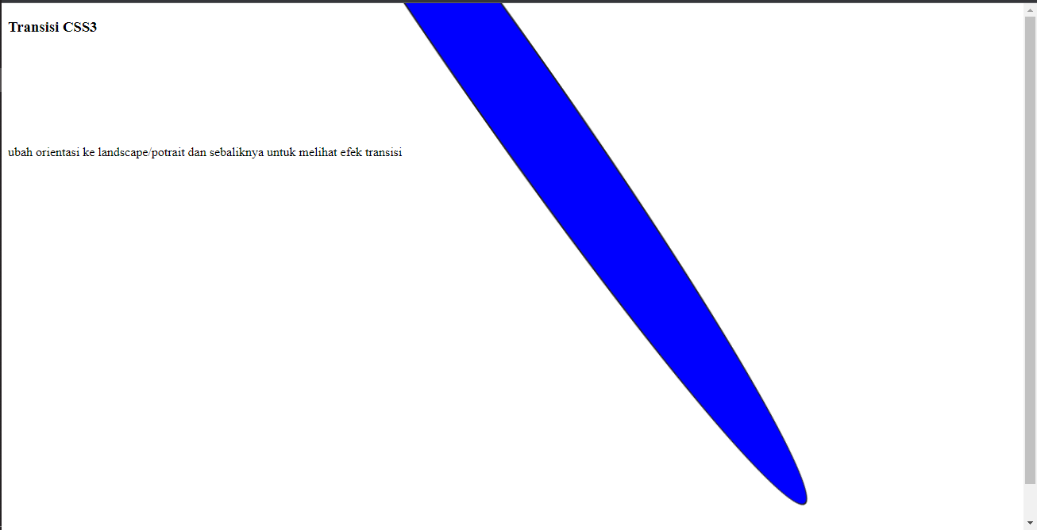

Ukuran smartphone

